Kadavergrotten

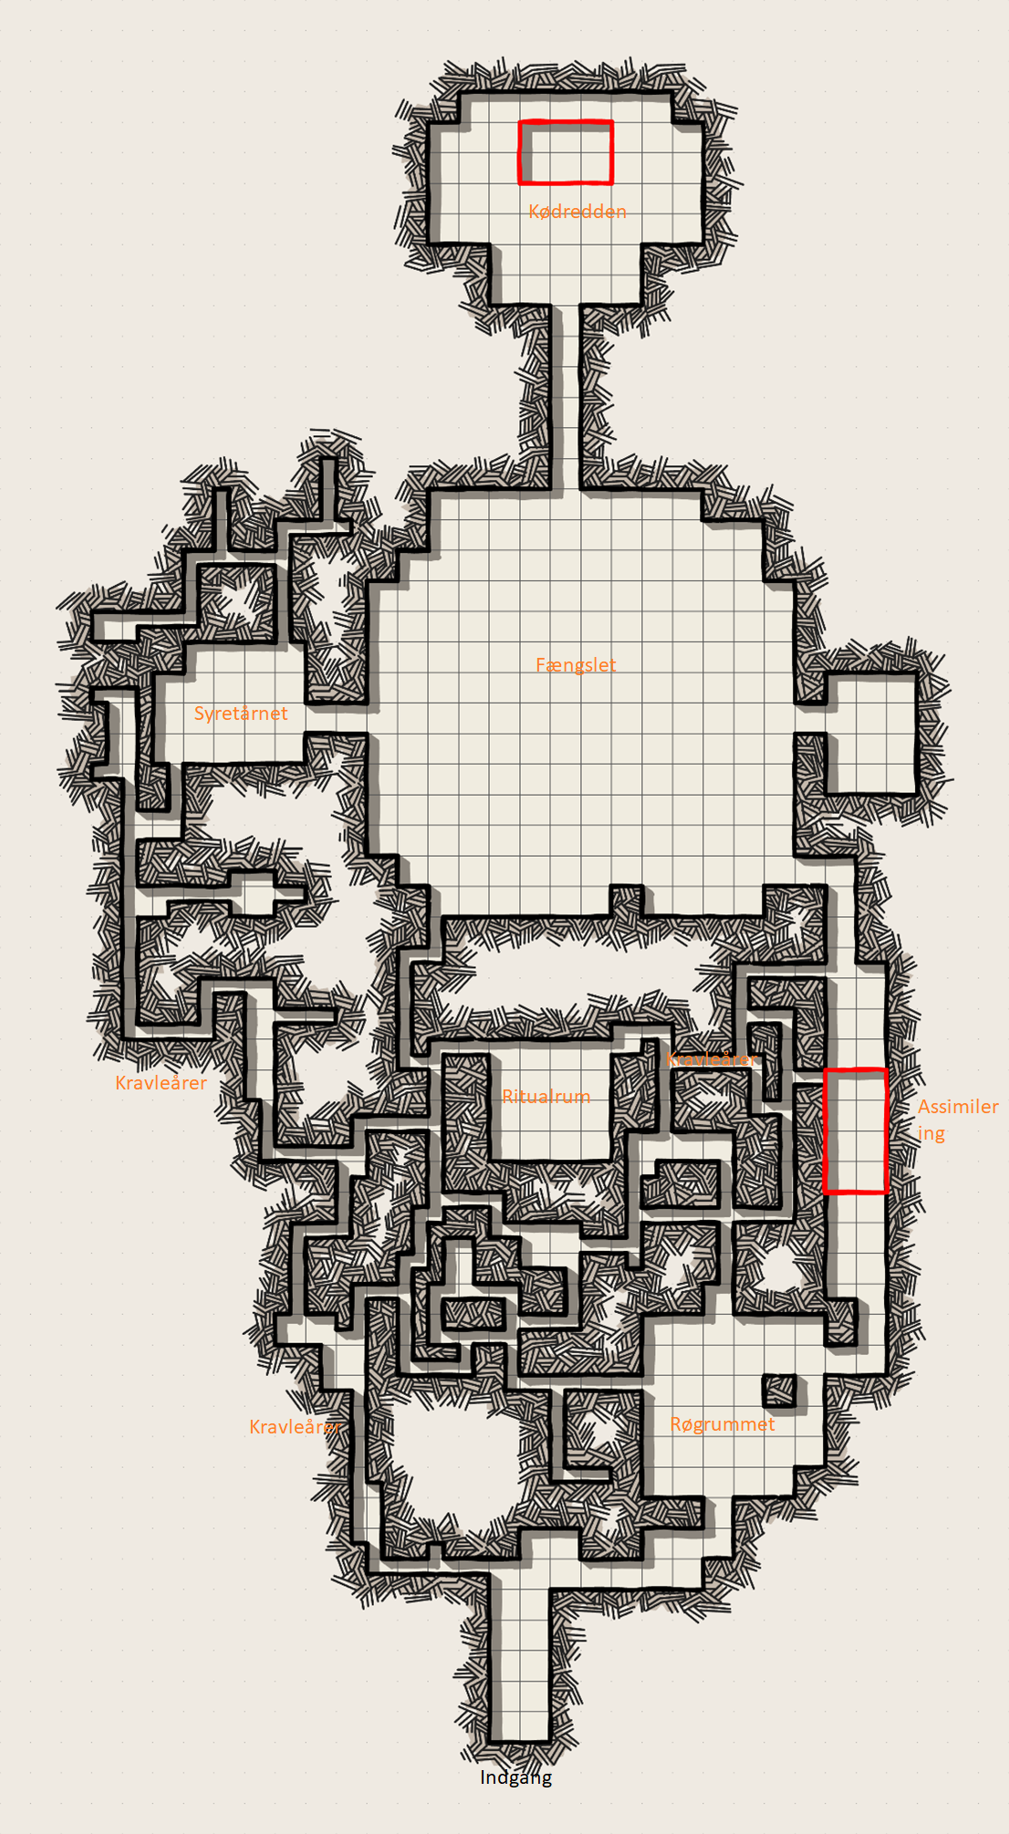

# Udenfor grotten

**Skelet ruiner**

Ude foran er der kommet 4 bygningsruiner lavet af skelet.  
Blod dug fra loftet, hvis bruger 1 minut på at drikke, kan man bruge hit dice til at heale.

**Skeletter i træer**

Foran grotten er det ophængt skeletter i træer. Alle mangler toppen af kraniet, og mange er allerede smadret af tidligere eventyrer. De vækkes til live hvis en *kadaverfugl* flyver ind i hovedet på dem. **Kadaverfuglene** er **abberation ”parodi”** på **fugle**. Deres vinger er snaskede som kød, og deres fuglesang er hæs og får folk til at angribe det nærmeste. Der er få fugle tilbage.

Indgangen til grotten ligner en åben mund, i løbet af dagen åbner og lukker den sig én gang.

# Generel beskrivelse af grotten og kort

Grotten består af kød, knogler og andet væv. I stedet for dug er det blod. Men grotten er i en halv-døende tilstand, så huden på væggene er krakelerende.

Ca. hver **10. minut** kan der et **højt brøl** fra *Skrigeren* i det store firkantede rum, ”Fængslet”.

Den røde boks på kortet til højre er en **15 fods** **dybt hul** fyldt med **udøde og spyd.** De udøde bliver assimileret ind i grotten.

Røde boks øverst på kortet er 10 fod dyb blodpøl (se Kødredden for mere)

De enkelte rum

# Røgrummet

Loftet er fyldt med rødlig blodrøg. Medmindre man er prone eller Small sized er man blinded.

**Lys sensitivitet og Røg-shadow angreb**

Røgen er sensitiv over for lys og tyndes ud nær lyskilder, men dæmper også alt lys til 5 bright 5 dim light.

Først forsøger røgen af slukke lyset (DC 13 Dex Save) ved at en hånd manifesterer sig og prøver at gribe om det.

Hvis lyset ikke slukkes eller tændes igen, angriber røgen (***Shadow Strangler***)***.*** Den forlader ikke rummet.

# Assimileringsrummet

15 fod dybt hul med spyd. Hullet har masser af lig der integreres i gulvet, ***Zombies.***

Med ca. 20 cm. mellemrum på væggene og loftet er der knogler der stikker ud, de største og mest stabile er ***Dread.*** Disse er tunge nok til at kunne bære folk hvis man ville kravle, men angriber først når spillerne er i en træls position (nede i pittet, mens man kravler på dem, tager deres ringe).

Loot:

* Blandt ligene kan findes:
  + 350 sp, 400 cp, 75 gp.
  + Gems: 3x 10 gp
  + 1x 40 gp ring på ***Dread*** finger der stikker ud fra væggen.

Spyd I sydenden er ødelagt af spillere.

# Kravleårene

Tunnelsystem hvor blod flyder i højere grad. De fleste steder er der kun plads hvis man er Small sized, ellers skal man squeeze. Fyldt med fugleinfesterede mennesker ***Derro Crawler*** og levende blod ***Blood-Borne Ooze***, der angriber fra flere fronter.

## Ritualrummet

I midten af tunnelsystemet er småt rum. Skinnende objekter i mærkelige rituelle mønstre.

* Loot
  + 500 cp, 60 gp, 500 sp.
  + Magic item: *Globe of Light*

# Fængslet

Cirkulært rum med høje, massive knogler der står langs væggene som et bur. Mange af knoglerne er nu knækkede.

Inden man når rummet høres high pitched skrig.

Eneste levende er kæmpe muteret kødklump ***The Screamer***, som leger med mumificerede dyr og Giants kranier. Skrigeren har et halsbånd der er en blodåre der er forbundet til loftet. Blodåren er næsten rådnet væk. Screameren ligner blanding mellem hund og brugde (hajen).

Ser ethvert levende dyr som prime target for næste legetøj.

Loot:

Giant legetøjs kranie:

* + [Indsæt noget guld eller andre spændende sager, gerne high weirdness]

**Mumie legetøj**

Et lille rum i højre ende indeholder en række forskellige dyr ophængt i tarm-lignende ræb.

* Legetøjet:
  + Taget

# Syretårnet

30 fod ned, 60 fod til loftet.

Væggene er fyldt med syre der giver skade hvis kravler, og i bunden er syrepøl.

Her var før et stort, askefarvet menneskehjerte, som var forbundet med tykke blodårer til væggene. Formålet med grotten var at gro hjertet. Grotten er døende fordi spillerne har nakket hjertet.

# Kødredden

**Beskrivelse**

Løber blod op og ned ad væggene.

I midten af rummet er 10 fod blodpøl, hvor fugle flyver op og ned i. I pølen er deres levende rede, ***Gibbering Mouther.*** Fuglesangen er forfærdelig.

Loot:

* Redden har:
  + Potion of Extra Growth (Bliver Huge, 1d8 skade i stedet for 1d4)
  + Potion of Water Breathing
  + Gems: 3x 10 gp
  + 550 sp, 40 gp
  + To Longswords bundet sammen med 10 ft reb.
  + 10x Rådne rations.

Gibbering Mouther er kæmpe, levende fuglerede. Det er her kadaverfuglene bliver dannet og lever.

Combat & Stat Blocks

Hvis de befinder sig i kravleårerne, vil det i størstedelen af tilfældene være *Derro Crawler* og/eller Blood Ooze der angriber, da de frit kan bevæge sig derinde

# Random encounter table

Antallet af monster der dukker op afgøres af DM. De kan også blandes. Tabellen i sig selv er også bare vejledende, jeg har ikke rigtigt brugt den :D.

|  |  |
| --- | --- |
| **Kast** | **Monster** |
| 1 | Fleshseeker Ghoul |
| 2 | Skeleton Warrior |
| 3 | Shadow Strangler (flavor som blodrøg) |
| 4 | Zombie |

DREAD 
Small undead, /awful evil 
Armor Class 1 3 
Hit Points 26 (4d8 8) 
Speed fly 30 ft (hover) 
STR 
15 (+2) 
DEX CON INT WIS CHA 
s (+2) 14(42) 6(.2) 8(.1) 5(.3) 
Dan-age Vulnerabilities Bludgeoning 
Dan-age Immunities Poison 
Condition Immunities Exhaustion, Poisoned 
Senses Darkvision 60 ft., Passive perception 9 
Languages Understands all languages it knew in life 
but can't speak 
challenge 1/2 (100 XP) 
Unliving Warrior. The dread has proficiency with all 
weapons. 
Habitual Height The dread can fly only so long as it 
is within 5 ft. of a solid surface, 
Bonesense The dread can pinpoint, by scent, the 
location of any creature with bones within 20 ft. of 
it, and does not suffer disadvantage for attacking a 
creature with bones that it cannot see. 
Actions 
Dread Grasp Melee Weapon Attack: +4 to hit, reach 
5 ft., one target. Hit: 4 (Id4* 2) bludgeoning 
damage and the creature is grappled (escape DC 
A creature grappled in this way cannot speak or 
breathe. and must succeed on a DC 12 Wisdom 
saving throw at the start of each Of its turns or be 
Frightened until the beginnng of its next turn, 
Throttle One creature grappled by the dread must 
succeed on a DC 12 Constitution saving throw or 
take 2d8) Sludgioning damage and lose its 
breath, it was holding it, or take half as much 
damage on a failure, 
Reactions 
Wrest Weapon As a reaction when it is missed with 
a melee weapon attack by a creature it has 
grappled, the dread forces the creature to make a 
DC 12 Strength saving throw, On a failure, the 
grapple ends and the dread pulls the attacker's 
weapon from from its hands, SKELETON WARRIOR 
Me undead, /awfi.'/ 
Armor Class (Armor Scraps) 
Hit Points 13 (2d8 4) 
Speed 3 0 ft 
STR DEX 
10fr0) 14 (+2) 
CON 
15 (+2) 
INT CHA 
6(-2) 8 
Dam* Vulnerabilities Bludgeoning 
Dam* Immunities Poison 
Condition Immunities Exhaustion, Poisoned 
Senses Darkvision 60 ft., Passive Perception 9 
Languages Understands all languages it knew in life 
but can't speak 
challenge 1/4 (SO XP) 
Unliving The Skeleton has proficiency in all 
martial weapons and 
Bonesense The skeleton can pinpoint. by scent. the 
location of any creature with bones within 20 ft. of 
it. and does not suffer disadvantage for attacking a 
creature with bones that it cannot see 
Rattle A creature that hits the skeleton with a 
melee attack that deals bludgeoning damage must 
succeed a OC 12 Wisdom saving throw or be 
Frightened until the end of its next turn as it feels 
its own skeleton twitch slightly. 
Actions 
Shortsword Melee Weapon Attack: +4 to hit, reach 
5 ft., one target. Hit: 5 (166 2) piercing damage. 
Shortbow. Ranged Weapon Attack: +4 to hit, range 
80/320 one target, Hit: 5 (Id6 2) piercing 
damage, 
Reactions 
AS a reaction when a creature the 
skeleton can see reduces an undead ally of the 
skeleton's to O hit points, the skeleton moves up to 
10 ft towards the creature. FLESHSEEKER GHOUL 
Medium undead chaotic evil 
Armor Class 
Hit Points 63 (14d8) 
Speed 40 
STR DEX CON INT CHA 
15 (+2) 1090) 7(.2) 10(+0) 6(.2) 
Dam* Immunities Poison 
Condition Immunities Charmed, Exhaustion, 
Poisoned 
Senses Darkvision 60 ft, Passive Perception 10 
Languages Common 
challenge 1 XP) 
Snatcher. If the ghoul has a creature grappled, it 
may Dash as a Bonus Action, 
Disease-dB/cod A creature that deals piercing or 
slashing damage to the ghoul with a melee attack 
must succeed on a DC 10 Constitution saving 
throw or contract Ghoul Fever. 
Actions 
FleshripperBite Melee Weapon Attack: +3 to hit, 
reach 5 ft.. one creature. Hit: 4 (Id64 1) piercing 
plus 5 (IdlO) necrotic damage. 
Death Grig Melee Weapon Attack; to hit, reach 
5 ft., one target Hit; 7 (2d4 2) slashing damage 
and the target is grappled (escape DC 1 2), A 
creature that ends its turn grappled in this Way 
must succeed on a DC 10 Constitution saving 
throw or be paralyzed until the beginning of its 
next turn. 

Ghoul Fever. A creature with Chou' Fever cannot 
recover levels of ex%ustion, and must mgke DC 
10 Constitution saving throw each time it 
completes long rest or acquire a level of 
exhaustion. A creature dies while infected 
rises immediately as a ghoul. ZOMBIE 
Medium evil 
Armor Class 8 
Hit points 22 (3d8+ 9) 
Speed 20 ft. 
13 (+1) 
16 (+3) 
Saving Throws Wis +0 
Damage Immunities poison 
Condition Immunities poisoned 
INT 
WIS 
CHA 
Senses darkvision 60 ft., passive perception 8 
Languages understands the languages it knew in life but 
can't speak 
Challenge 1/4 (50 XP) 
Undead Fortitude. If damage reduces the zombie to O hit 
points, it must make a Constitution saving throw with a DC 
of S damage taken, unless the damage is radiant or 
from a critical hit. On a Success, the zombie drops to hit 
point instead. 
ACTIONS 
Slam. Melee Weapon Attack; +3 to hit, reach 5 one target. 
Hit: 4 (Id6+ l) bludgeoning damage 

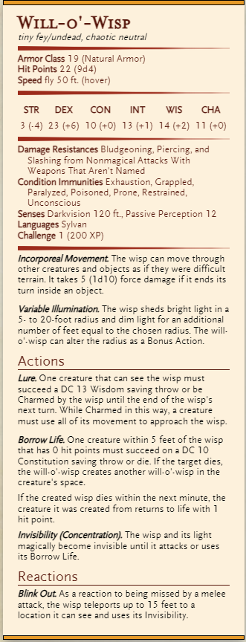

DERRO CRAWLER 
Medium humanoid evil 
1 3 (Leather Armor) 
Hit Points 13 (4d8 8) 
Speed 3 0 ft. 
STR DEX CON INT CHA 
10(+0) 14(+2) 12 (+1) 11 (+0) s 9(-1) 
Skills Stealth 
Senses Darkvision 120 ft. (penetrates magical 
darkness), Passive Perception 7 
Dwarvish, Undercommon 
Ch nge 1/4 (50 XP) 
Sunlight Sensitivity. While in sunlight, the derro has 
disadvantage on attack rolls, as well as on Wisdom 
(Perception) checks that rely on sight. 
Scuttling Advance The derro can crawl at its full 
movement speed, and does not suffer disadvantage 
on attack rolls as a result Of being prone. 
Resistance The derro has advantage on 
saving throws against spells and other magical 
effects. 
Actions 
HookedSpear. Melee Weapon Attack: +2 to hit, 
reach 5 ft, one target. Hit: 3 (Id6) piercing 
damage. If the target is Medium or smaller, the 
derro can choose to deal no damage and knock it 
prone. 
Crossbow. Ranged Weapon Attack: +4 to hit, range 
80/320 ft., one target. Hit: 6 (Id8 + 2) piercing 
damage. 
Uncanny Fixation (l/Day). The derro chooses one 
hostile creature it can see at random. For the next 
hour or until the creature dies, the derro has 
advantage on attack rolls and Wisdom-based 
checks directed at the creature, and disadvantage 
on attack rolls on attack rolls that target any other 
Reaction 
Mad Lunge. As a reaction to missing with a melee 
attack, the may add 5 to its attack If it 
does, the target may make an attack of opportunity 
against the derro. BLOOD-BORNE OOZE CR 1/4 AMBUSHER (50 XP) 
Tiny Ooze, Typically Neutral Evil 
Armor Class 13 (natural armor) 
Hit Points 14 (4d4 + 4) 
Speed 20 ft. 
DEX 
15 (+2) 
Skills Stealth +4 
CON 
WIS 
CHA 
13 (+1) 
1 10 (+0) 
Condition Immunities blinded, charmed, deafened, exhaustion, 
flanked, prone 
Senses blindsight 60 ft. (blind beyond this radius), passive 
Perception 10 
Languages — 
Proficiency Bonus +2 
Amorphous. The ooze can move through a space as narrow as I 
inch wide Without squeezing. 
False Appearance. While the ooze remains motionless, they are 
indistinguishable from a pool Of blood. 
ACTIONS 
Pseudopod. Melee Weapon Attack: +4 to hit, reach 5 ft., one 
target. Hit: 4 (Id4 + 2) bludgeoning damage plus 2 (Id4) necrotic 
damage. If the target is a creature Who isn't a Construct or 
Undead, they must succeed on a DC Il Constitution saving 
throw or the ooze melds into the target's body. While inside a 
creature, the ooze has total cover against attacks and Other 
effects originating outside that host. 
If the host creature takes 5 damage or more on a single turn 
from a source Other than the ooze, the ooze must succeed on a 
DC 12 Constitution saving throw at the end Of that turn or exit 
the host, entering the nearest unoccupied space Of the ooze's 
choice. A cure ailment power, protection from poison spell, or 
lesser restoration spell cast on the host also forces the ooze out. 
By spending 5 feet Of their movement, the ooze can voluntarily 
leave the host's body. 
Crimson Feast (Inside Host Only). The ooze consumes their host 
creature's bodily fluids. The host must make a DC Il Constitution 
saving throw. On a failed save, the host takes 5 (2d4) necrotic 
damage and is poisoned until the end Of their next turn. On a 
successful save, the host takes half as much damage and isn't 
poisoned. 

THE SCREAMER 
Huge aberration (Giant), Chaotic evil 
Armor Class 13 (natural armor) 
Hit Points 114 (12612 36) 
Speed 20 ft. 
STR 
18 (+4) 
DEX 
CON 
17 (+3) 
INT 
CHA 
Senses passive Perception 8 
Languages — 
Challenge 4 (1 ,100 XP) 
ACTIONS 
Multiattack The Screamer makes two slam attacks. 
Slam. Melee Weapon Attack: +6 to hit, reach 5 ft., one target. Hit: 
11 (2d6 bludgeoning damage. 
Otherworldly Cry (Recharge 6). All creatures within 60 feet of 
the Screamer that cen hear it must make a DC 14 Constitution 
saving throw. On a failure, a creature becomes paralyzed until 
the end of its next turn end takes 7 (2d6) psychic damage. On a 
success the target is not paralyzed and takes half damage. 

Blindsight 60 ft, end of

Screamers next turn

40 ft speed.

5/6 Recharge.

Intelligence frem for Wis

På gibbering

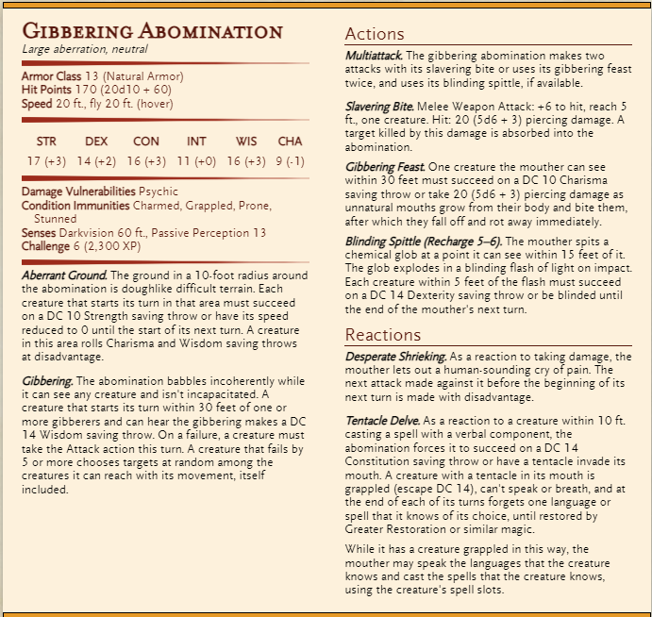

Billeder af enkelte monster

**Fleshseeker Ghoul**

HUMAN FLO\X/ER 
CORPUS_ANIMA 

**Derro Crawler**

**Blodrøg / Shadow Strangler**

